**NAME: BHANDARWAR GAJANAN SANTOSH**

**SUBJECT NAME: HARD DISK DRIVE (HDD)**

**Introduction:**

Since the early days of civilization, mankind has been consumed with the desire

to record its history and culture. With the dawn of the computer age, society truly entered into a new era of information sharing and mass communication. The invention of magnetic media helped facilitate this need and provided a means for systematically recording data and information that could be retrieved or re-written at any point in time. For many years however, magnetic media was limited to the format of reel-to-reel tape. Although successful, tape media was cumbersome and required constant maintenance and supervision. Society needed a more reliable and rigid technology to store information. This need was met by the creation of the hard disk drive. Hard disk technology has endured a long and successful history; however, the same basic fundamentals from early designs remain even in the most advanced magnetic storage technology today.

**History:**

One of the earliest and most influential companies to develop magnetic media disk

storage technology was IBM. **The IBM 350 Disk File invented by Reynold Johnson ,was introduced in 1956 with IBM 305 RAMAC Computer.** For almost three decades, IBM dominated the industry with innovative advancements on an almost annual basis. Framing on much of the original concept of digital tape storage by the ERA Corporation and other previous tape innovations, IBM went to work on a new type of magnetic storage. IBM had amassed an elite team of engineers in the early 1950’s known to be true pioneers in their field. It was no surprise then that in 1956, IBM released a newly developed piece of hardware known as the 305 RAMAC. The RAMAC, short for Random Access Method of Accounting and Control, was the world’s first computer with a disk storage system.



Fig. 1 – The IBM 350 Disk Storage System

(IBM Archives)

The RAMAC 305 was included with the IBM 350 DSS that would eventually become the precursor to the modern computer hard disk. Consisting of fifty 24” magnetic platters, these discs maintained a total storage capacity of about 4.4 megabytes. Although the capacity is significantly small by today’s standards, this was considered to be absolutely enormous in 1956. Data on the RAMAC was stored in a similar fashion to how it was on 4 the older tape technology. Through the use of disk “heads”, data could be read or written by manipulating a magnetic coating on the surface of the platters. Similarly to tape media, data could be re-written almost an indefinite number of times. Because of the complexity and support required of the new hardware, IBM decided the best solution was

to lease the hardware rather than sell it outright. The initial “going rate” for the 350 was about $3,200 per month. Shortly after the 350’s inception, IBM went immediately back to work on improving the basic design. They quickly released the 355 just days later. When used with the 650 series of computer, the 355 storage units could be daisy-chained to double, triple, and even quadruple the amount of total storage. In the initial release of the 350 and 355 however, data was stored on only one side of the platter. Additionally, only one head was being utilized to read this data. Although perfectly functional, IBM engineers knew this technology could be easily improved. Future advancements included the inclusion of

multiple heads, utilization of both sides of the disc platters, and additional storage unit chaining. This not only increased capacity and the speed of data retrieval, but offered both upgradability and expandability (“Our History of”).

As computers began to seep more and more into the typical business infrastructure,

corporations realized the enormous potential for these machines in both financial and record-keeping capacities. IBM continued to release newer and more revised versions of the 350 disk technology. In the years following the 350 and 355 data unit, was the release of the IBM 1301 data storage unit. This offered increased storage, speed, and the use of air bearing-cushioned heads (Dayes, & Trader, 1999). The 1302 and 1311 followed shortly thereafter with the 1311 model being the first to introduce removable disc packs. 5 Improved speed and storage capacity continued with the subsequent release of models such as the 1405, 2305, 2314 and 2321. As desk and office dumb-terminals began to hit the market, IBM focused their hardware development on supporting mainframe storage systems. In the early 1970’s, they released several new data storage units starting with the

IBM 3330 direct access subsystem. These new units began to take shape into the type of equipment more commonly seen throughout the 1980’s and 1990’s. The 3330 was followed in order by the 3340, 3350, 3858, 3310, 3370, 3380 and finally the 3390. Each new unit significantly increased capacity with a considerably reduced physical size.



Fig. 2 – The IBM 3390 Expandable Direct Access Storage Device

(IBM Archives)

As computer technology advanced, and the cost associated with distribution and

manufacturing decreased, technology in the home also improved. An entirely new

industry was being formed for the home consumer. To support this growing market trend, new hardware corporations began springing up throughout the United States during the 1970’s. These companies offered competition and technological improvements to much of the newly available data technology. One large group of engineers from IBM, known internally as “the dirty dozen”, left the company to form a new corporation known as Memorex. Several of them later left to form another corporation known as Seagate. Seagate would quickly become one of the foremost leaders in home computer storage technology (Snyder, 2006).

**1.What is Hard Disk Drive(HDD).**

A **hard disk drive** (often shortened as hard disk, hard drive, or HDD) is a non-volatile storage device that stores digitally encoded data on rapidly rotating rigid (i.e. hard) platters with magnetic surfaces. Strictly speaking, “drive” refers to the motorized mechanical aspect that is distinct from its medium, such as a tape drive and its tape, or a floppy disk drive and its floppy disk. Early HDDs had removable media; however, an HDD today is typically a sealed unit (except for a filtered vent hole to equalize air pressure) with fixed media.  
A computer hard disk drive (HDD) is the mechanism that controls the positioning, reading and writing of the [hard disk](http://searchstorage.techtarget.com/definition/hard-disk), which furnishes data [storage](http://searchstorage.techtarget.com/definition/storage). A hard disk drive -- often shortened to *hard drive* -- and hard disk are not the same thing, but they are packaged as a unit and either term can refer to the whole unit. Hard disk drives can be found in desktop computers, mobile devices, consumer electronics and enterprise storage [arrays](http://searchstorage.techtarget.com/definition/array) in data centers.

### H:\Gaju Data\Gajanan.s.b\images-4.jpg

**Structure of HDD:**

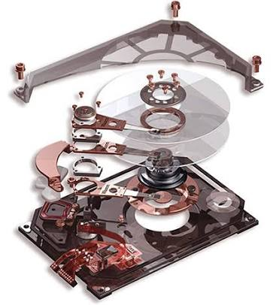

**How hard drive works?**

A hard disk is a sealed unit containing a number of platters in a stack. Hard disks may be mounted in a horizontal or a vertical position. In this description, the hard drive is mounted horizontally.

Electromagnetic read/write heads are positioned above and below each platter. As the platters spin, the drive heads move in toward the center surface and out toward the edge. In this way, the drive heads can reach the entire surface of each platter.

### [Different Types Of PC Hard Disk Drives (HDD)](http://www.saypoint.net/2012/05/different-types-of-pc-hard-disk.html)

[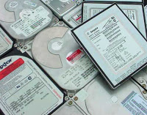](http://2.bp.blogspot.com/-SDAvENb7q-w/T8WZIA6PMBI/AAAAAAAAB6o/6VTg4D8IOWc/s1600/Hard-Disk-Drive-In-Market.jpg)

**Hard Disk Drive:** Hard disk is an important part in pc which stores all software's ( including OS and Application software), user data, files and folder. It is a permanent memory storage type which can retain data after power interruption.

**Why it is called Hard Disk Drive:**    It is made up of concentric metallic disk fitted at a Spindle, bunch of head each placed one after the other to read data from both the side of each disk. These metallic disks are coated with magnetic material to store data. Since these disks are made up of hard metallic substance so it called hard disk.

[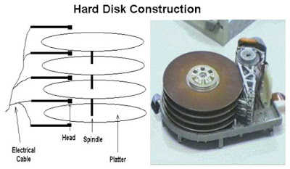](http://4.bp.blogspot.com/-q_HOaLfl9ho/T8WZWwLrdII/AAAAAAAAB6w/_93nTnXunuY/s1600/Construction-of-HDD.jpg)

**Different type of HDD:      Mainly five types of HDD available in market.**  
1.    IDE : Integrated Drive Electronics. IDE drives are also known as PATA drives( Parallel advance technology attachment )  
2.    SATA : Serial advance technology attachment   
3.    SCSI : Small Computer System Interface. SCSI is pronounced as scuzzy.  
4.    SAS : Serial Attached SCSI  
5.    External removable Hard Disk Drive

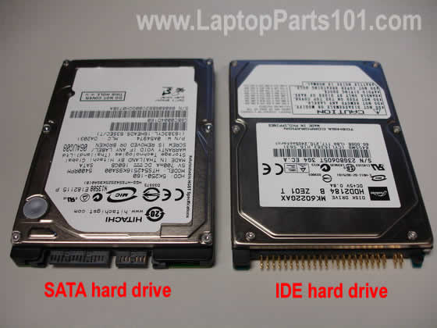   
  
**IDE / PATA (Integrated Drive Electronics Drive / Parallel Advance Technology Attachment Drive)**  
•    IDE/PATA Drives have usually 40 pins.  
•    IDE/PATA Drives offer 133 MB/sec transfer rate.  
•    It sends 8 bit data at a time.   
•    PATA Cables are used to connect PATA HDD. Two drives can be connected in a single pata cable. One as master and other as slave. The configuration of master and slave is done by different combination of jumpers in the hdd.

[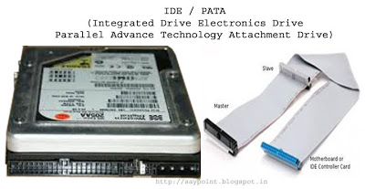](http://4.bp.blogspot.com/-aPmCZ5ITZZc/T8WaVTr2IhI/AAAAAAAAB64/NqnBx51hLOM/s1600/IDE-PATA-HDD.jpg)

**SATA (Serial Advance Technology Attachment Drive)**  
•    SATA Drives have usually 7 pins, 4 pins in pair of two for sending and receiving data and rest 3 pins are grounded.   
•    SATA Drives offers generally 300MB/sec transfer rate.  
•    It sends data bit by bit.  
•    SATA Cables are used to connect SATA HDD. Only one drive can be connected in a single sata cable.

[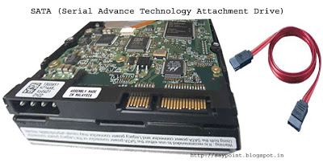](http://1.bp.blogspot.com/-h-wkpuAlnPg/T8WbZzwToxI/AAAAAAAAB7A/FwBXLO780QE/s1600/SATA-HDD.jpg)

**SCSI (Small Computer System Interface Drive)**  
•    SCSI Drives have usually 50 to 68 pins.  
•    SCSI Drive offers generally 640MB/sec transfer rate.  
•    This drives are hot swappable (means it can be attached or detached from system in running condition)    
•    SCSI cables are used to connect SCSI HDD. Maximum of 16 drives can be connected in a single scsi cable. Each hdd have a 8 bytes hexadecimal code known as WWN (world wide name) for its identification in the cable.

[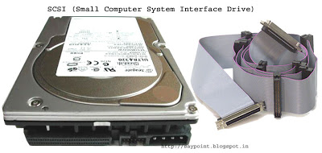](http://4.bp.blogspot.com/-MYiGOKvIqSg/T8WblRpT5EI/AAAAAAAAB7I/IDLxdC3vB3A/s1600/SCSI-HDD.jpg)

**SAS(Serial Attached SCSI Drive)**   
•    SAS Drives generally offers 805 MB/sec transfer rate.   
•    This drives are hot swappable.   
•    SAS Cables are used to connect SAS Drives. Maximum of 128 drives can be connected in a single sas cable.

[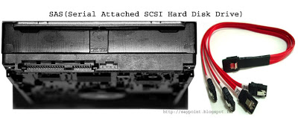](http://1.bp.blogspot.com/-alcjPLwUipc/T8Wbr4h-iPI/AAAAAAAAB7Q/-wTnpZ_FYyE/s1600/SAS-HDD.jpg)

**External removable HDD**  
This is the hard disk drives external to system typically connect via USB cable. It is removable in nature and features large storage options and portable design.   
**It can be use for :**   
•    Backup  
•    Data storage  
•    External boot disk for system  
•    Data cloning/recovery

[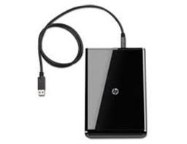](http://2.bp.blogspot.com/-lQQy864vi7k/T8WbyiKdurI/AAAAAAAAB7Y/_A4MamU1ixs/s1600/External+Reovable+Hard+Disk.jpg)

# The Four Major Components of a Hard Drive

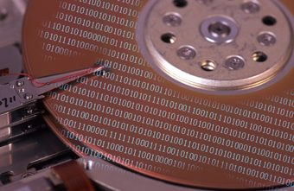

A hard drive is made up of several finely tuned components.

The hard drive, which typically provides storage for data and applications within a computer, has four key components inside its casing -- the platter (for storing data), the spindle (for spinning the platters), the read/write arm (for reading and writing data) and the actuator (for controlling the actions of the read/write arm). Only the most technically proficient IT professionals should attempt to work on the components inside a hard drive.

**PLATTERS:**   
Platter is a circular, metal disk that is mounted inside a hard disk drive. Several platters are mounted on a fixed spindle motor to create more data storage surfaces in a smaller area. The platter has a core made up of aluminium or glass substrate, covered with a thin layer of Ferric oxide or cobalt alloy. On both sides of the substrate material, a thin coating is deposited by a special manufacturing technique. This, thin coating where actual data is stored is the media layer.

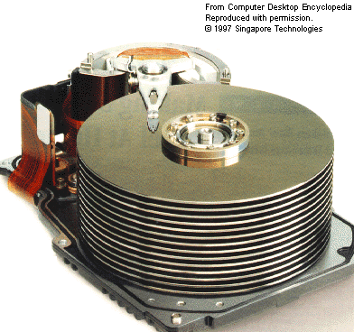

Hard drive platters

When the magnetic media is applied to the surface of the substrate material, a thin lubricating layer is applied to protect the material. This complex three layered media is discussed in detail as follows:

**THE SPINDLE MOTOR:**   
Spindle motor plays an important role in hard drive operation by turning the hard disk platters. A spindle motor must provide stable, reliable, and consistent turning power for many hours of continuous use. Many hard drive failures occur due to spindle motor not functioning properly

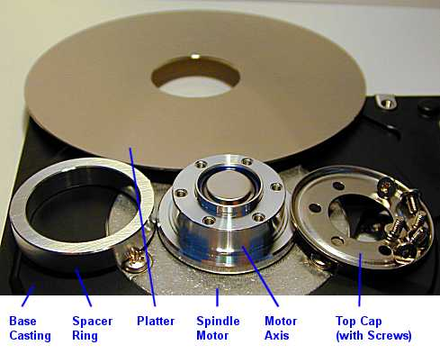

Spindle motorparts

## The Read/Write Arm

The read/write arm controls the movement of the read/write heads, which do the actual reading and writing on the disk platters by converting the magnetic surface into an electric current. The arm makes sure the heads are in the right position based on the data that needs to be accessed or written; it's also known as the head arm or actuator arm. There is typically one read/write head for every platter side, which floats 3 to 20 millionths of an inch above the platter surface.

## Actuator

The actuator or head actuator is a small motor that takes instructions from the drive's circuit board to control the movement of the read/write arm and supervise the transfer of data to and from the platters. It's responsible for ensuring the read/write heads are in exactly the right place at all times.

**CLUSTERS:**   
Sectors are often grouped together to form Clusters.

**READ/WRITE HEADS:**   
The heads are an interface between the magnetic media where the data is stored and electronic components in the hard disk. The heads convert the information, which is in the form of bits to magnetic pulses when it is to be stored on the platter and reverses the process while reading.

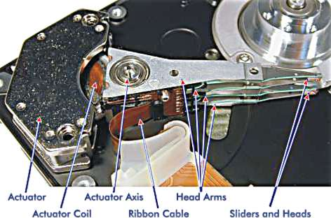

Hard disk heards

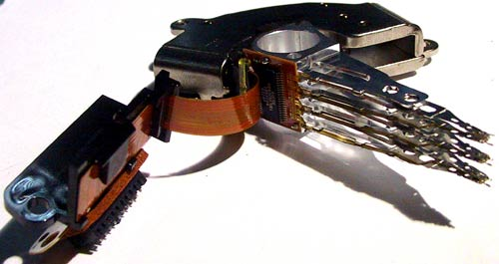

Hard disk heards

The heads are the most sophisticated part of the hard disk. Each platter has two read/write heads, one mounted on the top and the other one at the bottom. These heads are mounted on head sliders, which are suspended at the ends of head arms. The head arms are all fused into a singular structure called actuator, which is responsible for their movement.

**HARD DISK LOGIC BOARD:**  
Hard disk is made with an intelligent circuit board integrated into the hard disk unit. It is mounted on the bottom of the base casting exposed to the outer side. The read/write heads are linked to the logic board through a flexible ribbon cable.

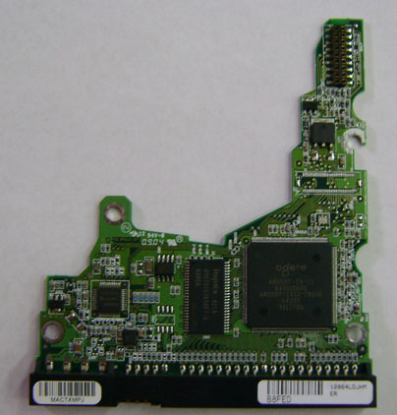

Hard disk logic board

## Other Components

As well as the casing on the outside of the hard disk that holds all of the components together, the front-end circuit board controls input and output signals in tandem with the ports at the end of the drive. No matter what the type of drive, it has one port for a power supply and one port for transferring data and instructions to and from the rest of the system

**How Data is stored on Hard Disk**

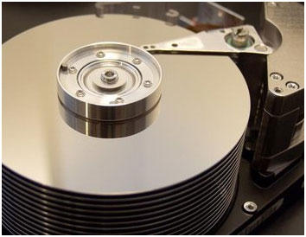

Hard disk stores information in the form of magnetic fields. Data is stored digitally in the form of tiny magnetized regions on the platter where each region represents a bit. To write a data on the hard disk, a magnetic field is placed on the tiny field in one of these two polarities: N-S – If North Pole arrives before the south pole and S-N – if the south pole arrives before the north pole while the field is accessed.  An orientation in the one direction (like N-S) can represent the ‘1’ while the opposite orientation (S-N) represents “0”. This polarity is sensed by integrated controllers built within the hard disk.

[Hard disk](http://www.engineersgarage.com/articles/hard-disk-tutorial-components-working) is a common data storage used in computers. Data is stored on the hard disk in the form of 0 and 1. Through this article we will find out how actually data is stored on the hard disk drive.  The part of the hard disk that stores the data is known as platter. Platters are circular disk made of a non magnetic material typically aluminum alloy, glass or ceramic and are coated with a thin layer (10-20nm) of a magnetic material. Platters are further separated in to the tracks and sectors where tracks are concentric circles while sectors are pie shaped wedges on the track.

# Sector

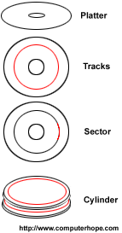

A division of a [storage medium](http://www.computerhope.com/jargon/s/stordevi.htm) on a [hard drive](http://www.computerhope.com/jargon/h/harddriv.htm) or [diskette](http://www.computerhope.com/jargon/d/disk.htm) that is a wedge shaped section of one of the circular tracks. Each arc is a **sector** that typically holds 512 bytes of [data](http://www.computerhope.com/jargon/d/data.htm) and is given a sector number for interleaving purposes, so the term sector may refer to the entire single arc. The size of sectors can be customized to maximize the storage area. For example, if a user stores smaller files, decreasing the sector size allows more files to fill the space without any leftover room. The illustration gives an example of what the sector would look like on a disk [platter](http://www.computerhope.com/jargon/p/platter.htm).

